**CODING ASSESSMENT – MONGODB (25/07/2025)**

use db

**>> One-to-One Relationship – Embedded Document**

**Insert:**

db.student.insertOne({

StudentName: "GeeksA",

StudentId: "g_f_g_1209",

Branch: "CSE",

PermanentAddress: {

Address: "XXXXX",

City: "Delhi",

PinCode: 202333

}

});

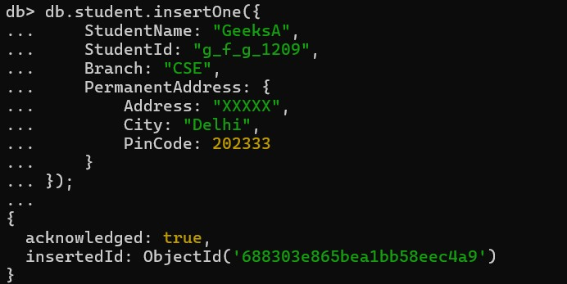

**Query:**

db.student.find({ StudentName: "GeeksA" }, { "PermanentAddress.Address": 1 }).pretty();

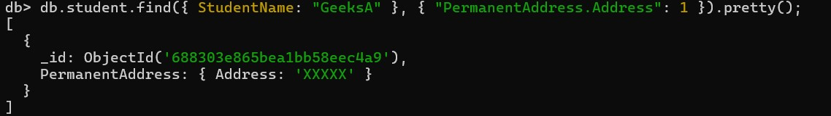

**>> One-to-Many Relationship – Embedded Documents**

**Insert:**

db.student.insertOne({

StudentName: "GeeksA",

StudentId: "g_f_g_1209",

Branch: "CSE",

Address: [

{

Type: "Permanent",

Address: "XXXXX",

City: "Delhi",

PinCode: 202333

},

{

Type: "Current",

Address: "YYYYY",

City: "Mumbai",

PinCode: 334509

}

]

});

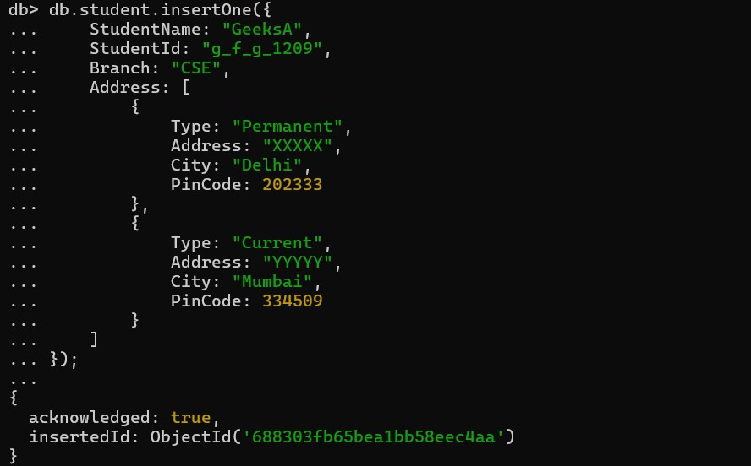

**Query:**

db.student.find({ StudentName: "GeeksA" }, { "Address.Address": 1 }).pretty();

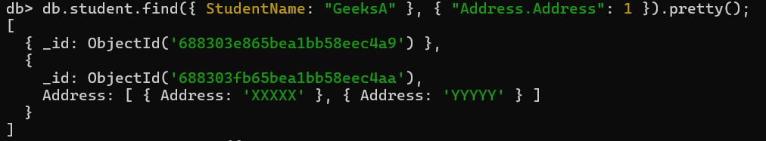

**>> One-to-Many Relationship – Reference Model**

**Insert (Separate Collections):**

db.teacher.insertOne({

teacherName: "Sunita",

TeacherId: "g_f_g_1209",

classIds: ["C_123", "C_234"]

});

db.class.insertMany([

{

ClassId: "C_123",

TeacherId: "g_f_g_1209",

ClassName: "GeeksA",

Studentcount: 23,

Subject: "Science"

},

{

ClassId: "C_234",

TeacherId: "g_f_g_1209",

ClassName: "GeeksB",

Studentcount: 33,

Subject: "Maths"

}

]);

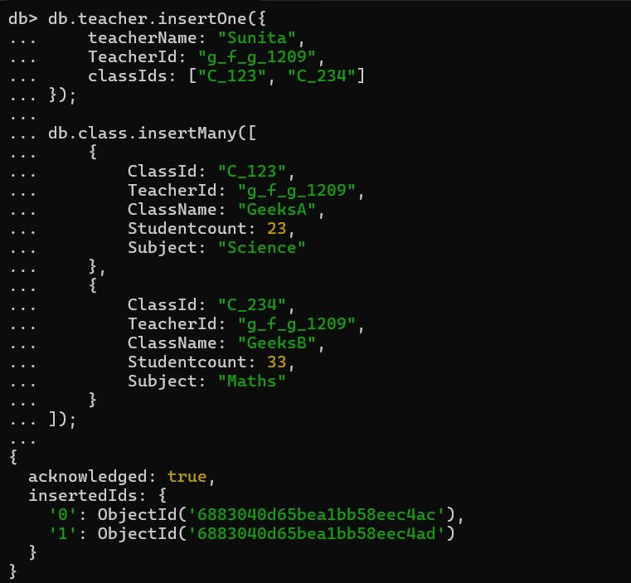

**Query:**

db.teacher.find({ teacherName: "Sunita" }, { classIds: 1 });

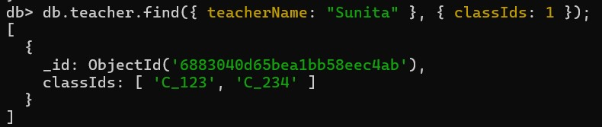

You can manually use classIds to query classes:

db.class.find({ ClassId: { $in: ["C_123", "C_234"] } });

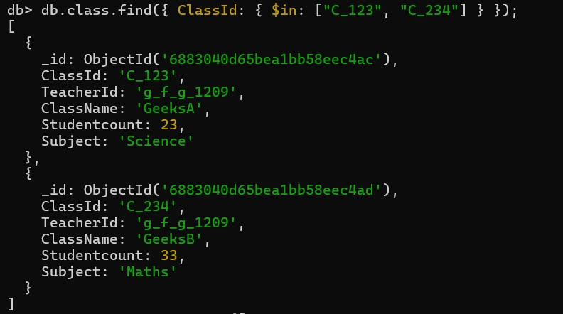

**>> Many-to-Many Relationship – Using $lookup**

**Insert Students & Courses:**

db.students.insertMany([

{ studentId: 1, name: "Lokanya", courseIds: [101, 102] },

{ studentId: 2, name: "Kiran", courseIds: [102] }

]);

db.courses.insertMany([

{ courseId: 101, courseName: "MongoDB" },

{ courseId: 102, courseName: "Python" }

]);

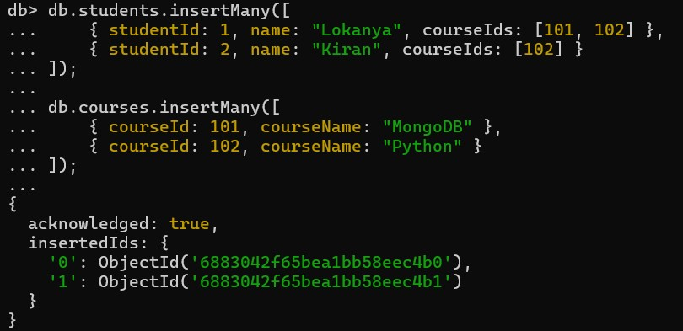

**Aggregation with $lookup:**

db.students.aggregate([

{

$lookup: {

from: "courses",

localField: "courseIds",

foreignField: "courseId",

as: "enrolledCourses"

}

}

]).pretty();

